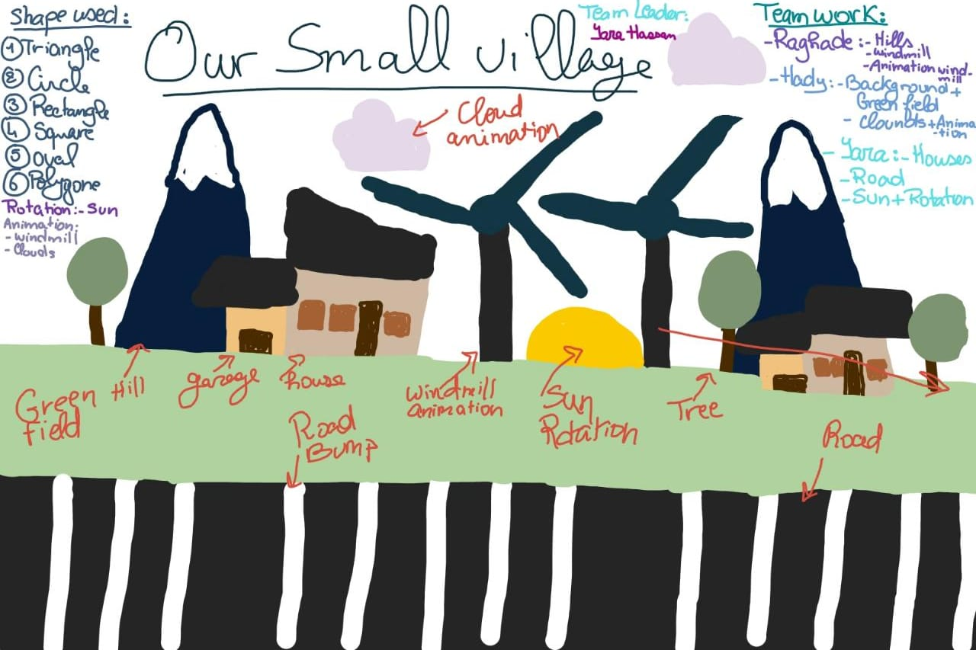Our Small Village Project

**This our project imagination before we began. We thought about doing a normal daily life in a small village.**

The shapes we used:

1. Triangle
2. Quad
3. circle
4. Polygon
5. Gl-Line

The rotation we done on:

* The sun.

The animation we done on:

* The windmill and the clouds.

Every team member work:

1. I began to shape the model of the hill and the windmill. Then, after shaping everything I assembled it into an object and put it in the position in the screen. After, I’ve done with the objects, I began to put animation for the windmill to spin.
2. I began to illustrate the background: sky and green field. Then, I began to shape the model of the clouds. Then, after shaping everything I assembled it into an object and put it in the position in the screen. After, I’ve done with the objects, I began to put animation for the clouds to move to the right of the screen then go back from the left side of the screen.
3. I began to shape the model of the 2 houses, the sun, the road and the road bumps. Then, after shaping everything she assembled it into an object and put it in the position in the screen. After, I’ve done with the objects, I began to put rotation for the sun to rise from the middle.